 | VIDEO EDITOR
Name | Manish Kumar Shoryan
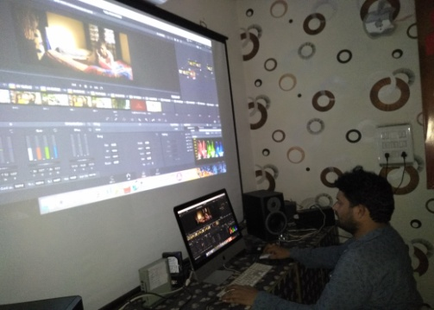 | 919999872543, 919521186128 (Home)  manishk2009@yahoo.com  Vill – Sirshi, The- Loharu , Dist- Bhiwani  Haryana - 127201  Birth Date: 4th Aug 1988  Gender: Male  Nationality: Indian  Marital Status: Married

Career Objective - To Gain First Hand In Media & Using My Skills and Commitment to Perform Quality Work in Your Renowned Company.

EDUCATION - Graduation ( BMC ) from Guru Jameshwar University, Hissar
Senior Secondary from Ajmer Board, Rajasthan in year 2006

Professional Experiences
1st March 2019  Aug 2018 to Feb 2019  Feb 2016 to July 2018  Jan-2015 to feb 2016  Dec. 2010 to jan 2015  2010  Jan 2010 -dec  Jan 2009 – Jan 2010 | RICHMOND GLOBAL SCHOOL  AM FILMS GURGAON ( Work For SWAYAM and MOOCs)  Make online educational videos  Neelam Films, Delhi  Icare Learning ( Gurgaon)  Narayan Seva Sansthan Udaipur (NGO)  as Senior Editor with Dev Darshan producing spiritual and social based programs for Colors, Star, Aastha, Sanskar, Shardha, Zee and Many others Channels.  Freelance Video Editor For ZEE NEWS  Promo Editor/ News Editor  HAR KHABAR delhi  Promo Editor/Senior Editor  Aashirwad Channel Udaipur  Name of Program  Reality Show - Karmraj ki adalat  Comedy show- Hasoda no-1  Documentary – Maan,  Daily soap- Nari Shakti , Roti Kapda aur ek Kamra etc

Dec. 2008 - Jan 2009 | Promo Editor/Chief Video Editor  Pal Pal Prassanta Television / Showtime Udaipur  Rajsthan India  Name of Program  Reality Show - Mega Dance  Reality Show - Mega Antyaxri  Daily soap - Camera Aap Ke Ghar  Reality Show - Voice Of Pal Pal  And Many Story & Channel Program Promo
Dec. 2006 – Nov 2008:  March 2006 –  May 2007:  Nov 2005 –  March 2006: | Senior Editor  ETV Rajasthan Jaipur  Name of Program  Comedy show– Rangilo Rajasthan  Fiction , Sangini, Vibs  Daily soap – Dastan a jurm , Rasoi Se  Tv 99  Jaipur  Promos and News  Offline Editor  Akay Film Studio Delhi  Astha, Sanskar Jagran Sony… (Freelance)  Capturing, editing, Recording, Cutting Media  Worked in ESSEL SHYAM COMMUNICATION for 14 Month as Coordinator of Aaashirwad Channel.  Also qualify for Lok Shabha TV as a Video Editor.

Linear Editing
Feb 2005 – July 2005: Worked as Linear Editor
AKAY Films Studio (Beta 2600P, 2800P,)
(Beta 70P, 50P)

Career Level: Mid Career (Over 13 Years experience)
Notice Period to Work: 15 Days or less

SOFTWARE KNOWN
- FCP ( Final Cut Pro)
- Adobe Creative Cloud
- Adobe Premiere Pro
- DaVinci Resolve
- Avid Express, Avid Liquid Express
- Adobe Photoshop
- Adobe After Effects
- Adobe Premier
- Sound Forge Motion, Live Type

Here is I am Sharing Some of Link of My Work…
https://www.youtube.com/watch?v=p8OhEKfv5_Q
https://www.youtube.com/watch?v=qJH1SnoBKlQ
https://www.youtube.com/watch?v=_oo9uvpNM90
https://www.youtube.com/watch?v=3FE_uzO04H4
https://www.youtube.com/watch?v=7FQSxz84ecU
https://www.youtube.com/watch?v=6FfoguKDf6U
https://www.youtube.com/watch?v=vJcKc0sXxAU
https://www.youtube.com/watch?v=ewn01Utoyvc
https://www.youtube.com/watch?v=RZO4zEhunuQ
https://www.youtube.com/watch?v=RiVwgYvi-U8
https://www.youtube.com/watch?v=4t4_K1Xq5Sc
https://www.youtube.com/watch?v=LWeDeAHRCDk
https://www.youtube.com/watch?v=1R-JKNCgGc4
https://www.youtube.com/watch?v=9dN6Fft7VN0
https://www.youtube.com/watch?v=RFCLgNckBZw
https://www.youtube.com/watch?v=xi4mIuHDJXk
https://www.youtube.com/watch?v=YmJnDGcSmT4
https://www.youtube.com/watch?v=lzuty46Ekyc
https://www.youtube.com/watch?v=sS9pBNkOygg
https://www.youtube.com/watch?v=MwDU0cG3LzI

for More Link Please Visit on Youtube and Just Type “MANISH SHORYAN.

I assure you that here above information is true & shall give my potential do the best in your esteemed organization.

Place: Delhi
Manish Shoryan

